Self-Evaluation Test. Roskin et alii Political Science. An Introduction.

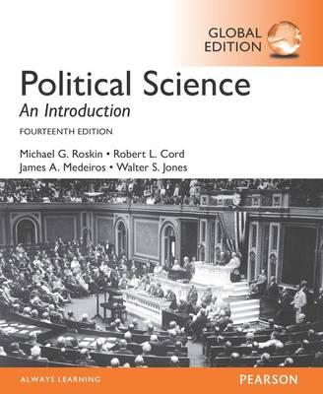

### Chapter 1 [Politics and Political Science](https://moodle.unive.it/course/view.php?id=1610)

### And 2 [Ways of Looking at politics](https://moodle.unive.it/course/view.php?id=1610)

What is a model in political science? What are the main purposes of using models? And the possible drawbacks?

What is a political system?

What were the main features of Behaviorism? Why was it important?

What is a normative approach to the study of politics?

What is the difference between political science and political theory (or normative approach to politics)?

What was Niccolò Machivelli main idea?

What was Confucius main idea?

What is a social contract?

What is, according to Hobbes, the main feature of human life before the social contract?

What is the main difference between Locke and Hobbes on this point?

What did Rousseau mean by “general will”?

What is the role of social classes in the Marxist theory?

Which of the following concepts did Machiavelli contribute to the study of politics?

a. social contract theory

b. the role of power in politics

c. the role of wealth in society

d. the connection between race and politics

Which thinker gave us the concept of the social contract?

a. Locke

b. Rousseau

c. Machiavelli

d. Hobbes

. Which thinker had a dark view of human nature, believing that humanity without a civil society would be “war of all against all”?

a. Machiavelli

b. Hobbes

c. Locke

d. Rousseau

The Founding Fathers particularly embraced Locke’s idea of the right to __________, which Locke felt was a primary reason why humans created civil society.

a. freedom of religion

b. private property

c. free speech

d. assembly

Some political scientists have inferred totalitarian themes in Rousseau’s idea of __________.

a. the general will

b. the social contract

c. the glory of the state

d. Marxist revolution

Which of the following is one reason why Marx believed the capitalist system would eventually collapse?

a. Capitalists would completely strip the world of its natural resources.

b. The bourgeois would rise up in revolution.

c. A severe economic depression was inevitable.

d. The global financial system would become too integrated.

While the application of Marxism in the Soviet Union was disastrous, Marx’s focus on the role of _________ in politics has been very insightful.

a. social democracy

b. the state of nature

c. social class

d. the social contract

Which of the following thinkers would be most likely to accept an aggressive king?

a. Hobbes and Machiavelli

b. Hobbes and Rousseau

c. Rousseau and Machiavelli

d. Locke and Machiavelli